How to disable a user from receiving Email
- Go to Admin Center
- In the search box type “Change User Email Notification”
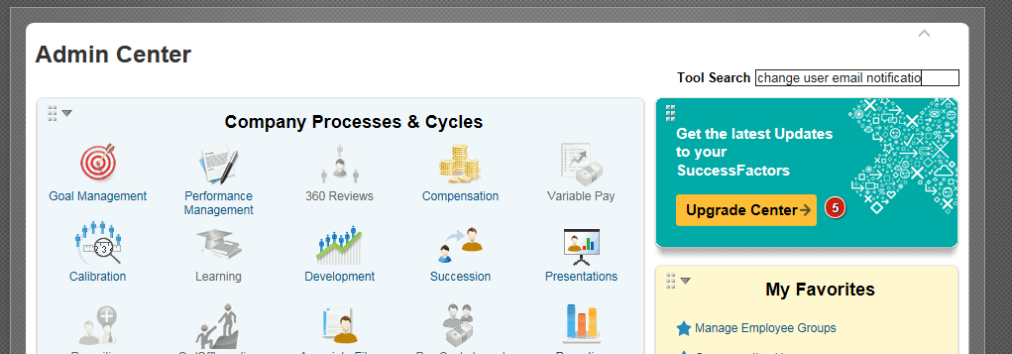
- Select change user email notification
- Search for the user who’s email you want to disable
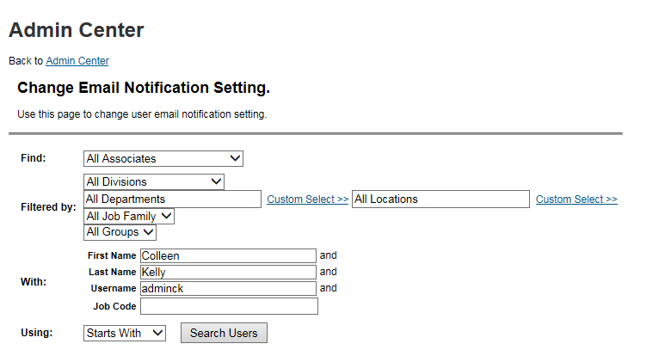
- Uncheck the email notification check box and click the Save the Setting button
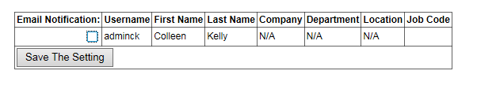
- Emails for this user are now disabled

